The Breadboard

Subject: Physics, engineering  Related Subjects: | Grade Level(s): 4  Length of Lesson: | Type: Inquiry / Design / Project  Keywords: Circuit; parallel; series

Lesson Overview
Use this section to describe at a high level what the lesson is. Should be no more than 3-4 lines.

Lesson Focus
What is the central question or phenomenon being investigated? What problem are they trying to solve?

Lesson Objective(s) | Students will learn to utilize the breadboard for creating circuits as a step to make circuit designing very easy and quick. They will:  - create a simple switch circuit using a push button switch, wires, battery and a LED light  - learn about other circuitry components and concepts such as series/parallel circuits, NC and NO switches, SPDT and SPST switches.

Lesson Timing

5 minutes | Introduce the Lesson
30 minutes | ...

Materials | - -Breadboard  - -Wires  - -Switches  - -LED lights
Instructor Prep | - Step 1
Related Resources | - List related lessons/ppts etc available from USC or outside, trusted orgs

Lesson Plan

Introduction
The breadboard is a piece of equipment that makes circuit design easy because you don’t have to twist any wires together. A typical breadboard looks like the one on the right. The properties of a breadboard includes:
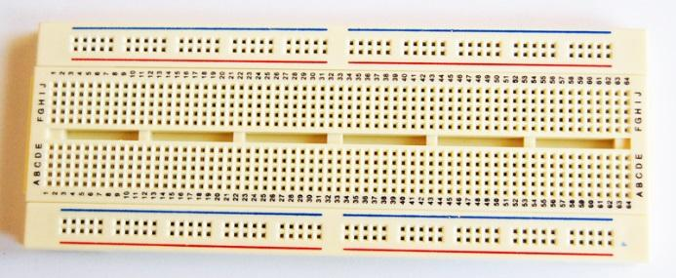
- 4 columns on the side each connected vertically
- Each column is connected (if you plug in the red wire, the whole column down is connected to the red wire)
- Holes in the middle of the board are connected horizontally (If you plug in something in the middle, then the four holes in the row are connected too)
Using the breadboard, it is easy to see the difference between series and parallel circuits.
- In a parallel circuit, each component (light, motor, or resistor) has its own branch. As a result, they all receive the same voltage.
- In a series circuit, two or more components share one wire. As a result they have to share the voltage.
The breadboard could also be used to show how different switches can work. The number of poles on a switch defines how many separate circuits the switch can control. So a switch with one pole, can only influence one single circuit. A four-pole switch can separately control four different circuits.

A switch’s throw-count defines how many positions each of the switch’s poles can be connected to. For example, if a switch has two throws, each circuit (pole) in the switch can be connected to one of two terminals.

- NO button switches (normally open): closes the circuit when button is pressed.
- NC button switches (normally closed): opens the circuit when button is pressed.
- SPDT (single pole, double throw): has three terminals, with one common pin
- DPDT (double pole, double throw): can control circuits. Basically two SPDT switches but can be switched together.

Procedure
Circuits
- Students will create a series and parallel circuit. Make sure they understand the differences between the two.
-An object in a parallel circuit is in its own “branch” while in a series circuit, the objects have to share the branch.
-Students should note that in parallel circuits the lights are both equally bright. In series circuits however, the two lights are dimmer since they have to share the voltage.

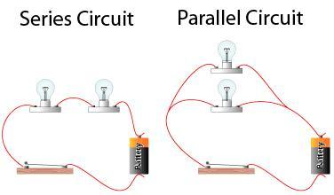

Switches
- Students will learn how to use different switches using the breadboard. The different switches are: NO push button, NC push button, SPST, and SPDT. Have them test out each switch in the circuits.

Wrap-up
End the lesson with some final discussions about what students designed/discovered. Connect their activity back to the focus question/problem, real world examples, and STEM careers.

Also include notes about any special cleanup considerations

Lesson Background for Teachers

Suggested Real-World STEM Connections
- List possible related Role Models in STEM (with details and links to more reading). Give suggestions for examples of scientists/engineers who are from underrepresented groups in STEM in related careers.
- List related real-world engineering problems and examples

Lesson Variations and Options
Include descriptions of alternative methods or ways to present things.

Explanation
Describe the background concepts and explanations behind the lesson. This can be more in depth than a teacher/instructor would actually share with students.

Key Concepts and Vocabulary
- Word 1: Grade Appropriate Definition
- Word 2: Grade Appropriate Definition

Safety Notes
- Safety instruction

